SUBMISSION COVER PAGE

**STUDENT ID**: CSE24-130

**STUDENT NAMES**: MILLICENT LONE TEBO

**COHORT**: 2025

**ASSIGNMENT TITLE**: OBJECT ORIENTED ANALYSIS & DESIGN

WITH JAVA

**PROGRAMME OF STUDY**: COMPUTER SYSTEMS ENGINEERING

**YEAR OF STUDY**: YEAR 2

FUNCTIONAL REQUIREMENTS

The goal in functional requirements is to identify the core functions that the banking system needs to support.

***1.CUSTOMER REGISTRATION***

QUESTION 1. How do customers register in the system?

.LECTURE: Customers should be able to create an account by providing basic information like full name, email, phone number, date of birth, address and set up a secure password.

#### **2. User Authentication**

* QUESTION 2. How should customers log into their accounts?
* LECTURE: Customers will log in using their username (email address) and password. Additionally, there should be an option for multi-factor authentication for added security.

#### **3. Account Management**

* QUESTION 3. What account management features should the system have?
* LECTURE: The system should allow users to:
  + View account balances.
  + Transfer funds between accounts.
  + Update their password and security settings.

#### **4. Transaction History**

* QUESTION 4. Should the system track user transactions? How?
* LECTURE: Yes, the system should keep a record of all transactions (deposits, withdrawals, transfers. Customers should be able to view transaction history and they should also be able to search transactions based on type e.g. deposit, withdrawal or date.

#### **5. Notifications**

* QUESTION 5. Should the system notify customers about certain events?
* LECTURE: Yes, the system should send notifications for:
  + Successful transactions.
  + Unsuccessful login attempts.
  + Security-related activities like password changes or suspicious logins.

NON -FUNCTIONAL REQUIREMENTS

Non-functional requirements specify the qualities or attributesthat the system must possess, this includes performance, security, reliability and usability.

***1.SECURITY***

The banking system must implement strong security measures, including encryption for sensitive data e.g. passwords and account numbers and two-factor authentication. This is because sensitive financial information requires robust protection against unauthorized access and data breaches.

***2. DESCRIPTION***

The system should provide fast response times for critical operations and transactions should be processed within a few seconds as users expect real-time performance when managing their accounts.

***3. RELIABILITY***

The system should be highly reliable, with a minimal risk of downtime and it should include redundancy and failover mechanisms to ensure availability because downtime or unavailability could lead to customer dissatisfaction and loss of business.

***4.SCALABILITY***

The system should be able to handle a growing number of users and transactions over time without significant degradation in performance because user base grows and the system must be able to support the increased load efficiently.

***5.USABILITY***

The user interface must be intuitive, easy to navigate, and responsive across different devices and the system should require minimal training for new users because if there is a seamless and user-friendly interface it enhances the customer experience and reduces frustration.

***6.ACCESSIBILITY***

The system should be designed to be accessible for users with disabilities, adhering to relevant accessibility standards.

Interviewer: Lecturer ( Themba Moeng)

Date& Time: 18/09/2025 at 08:00

Where: Online via Teams

***USECASE DIAGRAM***

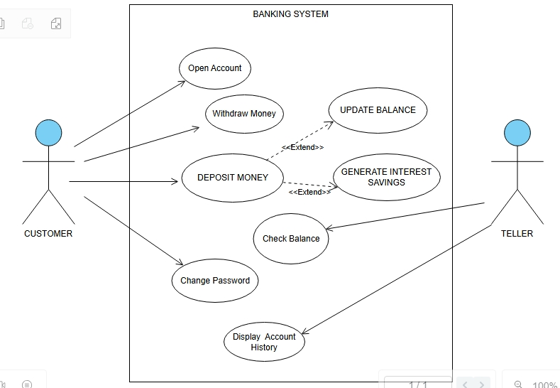

***CLASS DIAGRAM***

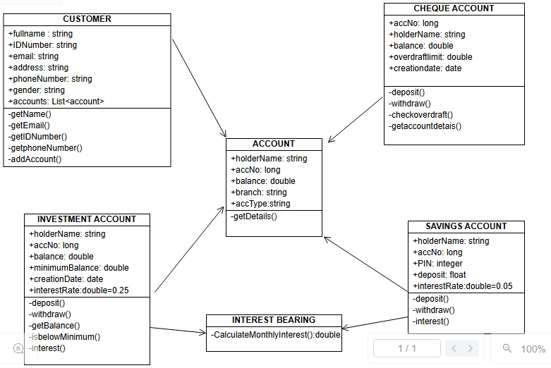

***SEQUENCE DIAGRAM***

***-LOGIN***

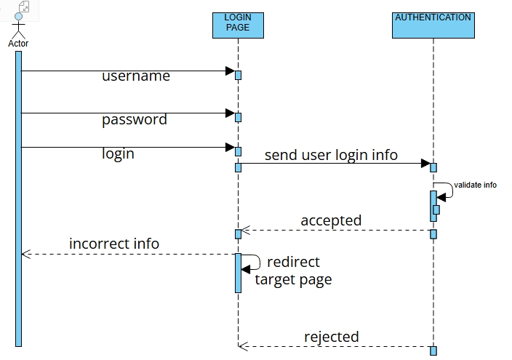

***-DEPOSIT FUNDS***

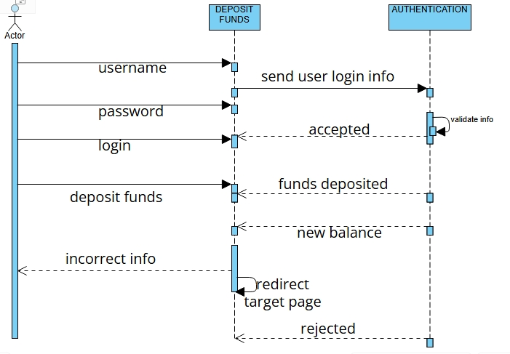

***STATE DIAGRAM***

